**UNIT 1**

**INFORMATION SYSTEM**

**Evolution of IS**

* **Transaction processing system:** These process data resulting from transaction, update operational database (records) and produce document or generate reports. E.g. sales and inventory processing and accounting.
* **Management information system:** System that provides information support for decision-making in the organizations. E.g. sales analysis, production performance e.t.c
* **Office automation systems (OAS):** system that was developed to support office and clerical workers. E.g. To develop documents (word processing), schedule resources (electronic calendars), and communicate (e-mail, voice mail, videoconferencing, and groupware).
* **Decision support system (DSS):** systems that provide interactive and ad hoc support for the decision making process of managers and other business professionals. E.g. product pricing, risk analysis system e.t.c
* **Executive information system:** Provide critical information from MIS, DSS and other sources, tailored to the information needs of executives. Examples: systems for easy access to analysis of business performance, actions of all competitors, and economic developments to support strategic planning.
* **Intelligent support system(ISS):** knowledge-based system(or expert system) that provide expert advice and act as expert consultants to users. Examples: credit card approval, process monitor, and diagnostic maintenance systems.
* **Knowledge management system:** knowledge-based systems that support the creation, organization and dissemination(to spread information) of business knowledge within the enterprise. Examples: intranet access to best business practices, sales proposal strategies and customer problem resolution systems.
* **Electronic commerce system:** enable transaction among organization and organization and customer. E.g. [www.dell.com](http://www.dell.com/)
* **Mobile computing:** Information systems that support employee who are working with customers or business partners outside the physical boundaries of their company, can be done over wire or wireless network.

**Classification of information system**

Information systems are classified by

* Organizational levels
* Mode of data processing
* System objectives and
* The type of support provided.

Classification by organizational levels

Typical information systems that follow the organizational structure are ***functional (departmental), enterprise, and inter-organizational.***

**Functional organization:** Hierarchical structures. The controlling authority, often called top management, coordinates with each management level and functional department to keep the organization running smoothly.

A functional organization analyzes the strengths and weaknesses of each member, groups them into categories and assigns them to tasks that best utilize their skills. Jobs that perform a similar function are grouped in functional areas. Each functional area contains employees with varied skills that are further grouped based on specialization and put in separate units or departments. Information systems which served these functional departments are called functional information systems.

**Enterprise organization:** While a departmental information system is usually related to a functional area, other information systems serve several departments or the entire enterprise. These information systems together with the departmental applications comprise the **enterprise information system (EIS).**

One of the most popular enterprise applications is **enterprise resources planning (ERP)**, which enables companies to plan and manage the resources of an entire enterprise. ERP systems present a relatively new model of enterprise computing now days.

**Inter-organizational:** Information systems that connect two or more organizations.

**Supply chain** describes the flow of materials, information, money, and services from raw material suppliers through factories and warehouses to the end customers. Supply chain includes both physical flows and information flows. Information flows and digitizable products (e.g., music and software) go through the Internet, whereas physical products are shipped.

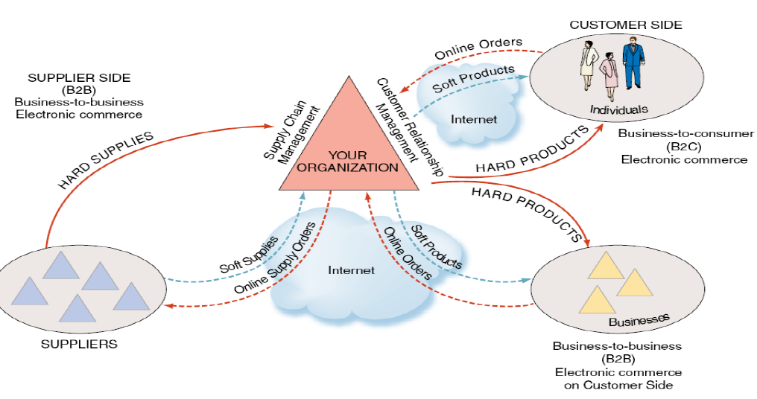

Figure: Inter-organizational system

**Classification by Mode of Data Processing**

* **Batch Processing Systems:** The transactions are collected as they occur, but processed periodically, say, once a day or week.
* **On-line Batch Systems:** The transaction information is captured by on-line data-entry devices and logged on the system, but it is processed periodically as in batch processing systems.
* **On-line Real-time Systems:** The transaction data capture as well as their processing in order to update records (and generate reports) is carried out in real-time as the transaction is taking place.

**Classification by types of support provided**

* **Clerical workers**, who support managers at all levels of the organization, include bookkeepers, secretaries, electronic file clerks, and insurance claim processors.
* **Lower-level managers**handle the day-to-day operations of the organization, making routine decisions such as assigning tasks to employees and placing purchase orders
* **Middle managers** make tactical decisions, which deal with activities such as short-term planning, organizing, and control.
* **Knowledge workers** are professional employees such as financial and marketing analysts, engineers, lawyers, and accountants. All knowledge workers are experts in a particular subject area
* **Office automation systems** (OAS's) typically support the clerical staff, lower and middle managers, and knowledge workers. OAS helps to develop documents (word processing and desktop publishing software), schedule resources (electronic calendars), and communicate (e-mail, voice mail, videoconferencing, and groupware).

**Functional Area Information System**

* As the name suggests, each FAIS supports a particular functional area within the organization.
* Examples are accounting IS, finance IS, production/operations management (POM) IS, marketing IS, and human resources IS.
* In **finance and accounting**, managers use IS systems
  + to forecast revenues and business activity,
  + to determine the best sources and uses of funds, and
  + to perform audits to ensure that the organization is fundamentally sound and that all financial reports and documents are accurate.
* In **sales and marketing**, managers use IS to perform the following functions:
  + ***Product analysis****: developing new goods and services*
  + ***Site analysis:*** *determining the best location for production and distribution facilities*
  + ***Promotion analysis:*** *identifying the best advertising channels*
  + ***Price analysis:*** *setting product prices to obtain the highest total revenues*
* In***manufacturing****,* managers use IS
  + To process customer orders, develop production schedules, control inventory levels, and monitor product quality.
  + They also use IS to design and manufacture products.
  + These processes are called *computer-assisted design (CAD) and computer-assisted manufacturing (CAM).*
* Managers in ***human resources*** use IS
  + to manage the recruiting process, analyze and screen job applicants, and hire new employees.
  + They also employ IS to help employees manage their careers, to administer performance tests to employees, and to monitor employee productivity.
  + Finally, they rely on IS to manage compensation and benefits packages.

**Qualities of information system**

* **Availability:** If information is not available at the time of need, it is useless. Data is organized in the form of facts and figures in databases and files from where various information is derived for useful purpose.
* **Purpose:** Information must have purposes at the time it is transmitted to a person or machine, otherwise it is simple data. The basic purpose of information is to inform, evaluate, persuade, and organize.
* **Mode and format:** The modes of communicating information to humans are sensory (through sight, hear, taste, touch and smell) but in business they are either visual, verbal or in written form. Format of information should be so designed that it assists in decision making, solving problems, initiating planning, controlling and searching. It should be simple, relevant and should highlight important points but should not be too cluttered up.
* **Decay :**Value of information usually decays with time and usage and so it should be refreshed from time to time. For example, we access the running score sheet of a cricket match through Internet sites and this score sheet is continually refreshed at a fixed interval or based on status of the state.
* **Frequency:** The frequency with which information is transmitted or received affects its value. Financial reports prepared weekly may show so little changes that they have small value, whereas monthly reports may indicate changes big enough to show problems or trends.
* **Completeness:** The information should be as complete as possible. For example -Hartz's model for investment decisions provides information on mean, standard deviation and the shape of the distribution of ROI (return of investment) and NPV(net present value). With this complete information, the manager is in a much better position to decide whether or not to undertake the venture.
* **Reliability :**It is just not authenticity or correctness of information; rather technically it is a measure of failure or success of using information for decision-making. If an information leads to correct decision on many occasions, we say the information is reliable.
* **Validity** : It measures the closeness of the information to the purpose which it purports to serve. For example, some productivity measure may not measure, for the given situation, what they are supposed to do e.g., the real rise or fall in productivity. The measure suiting the organization may have to be carefully selected or evolved.

**Managing information system resources:**

Managing information systems in modern organizations is a difficult, complex task. Several factors contribute to this complexity. First, information systems have enormous strategic value to organizations. Firms rely on them so heavily that, in some cases, when these systems are not working (even for a short time), the firm cannot function. (This situation is called “beinghostage to information systems.”) Second, information systems are very expensive to acquire,operate, and maintain.

A third factor contributing to the difficulty in managing information systems is the evolution of the management information systems (MIS) function within the organization. When businesses first began to use computers in the early 1950s, the MIS department “owned” the only computing resource in the organization, the mainframe. At that time, end users did not interact directly with the mainframe.

In contrast, in the modern organization, computers are located in all departments, andalmost all employees use computers in their work. This situation, known as *end user computing*,has led to a partnership between the MIS department and the end users. The MISdepartment now acts as more of a consultant to end users, viewing them as customers. Infact, the main function of the MIS department is to use IT to solve end users’ businessproblems.

As a result of these developments, the responsibility for managing information resourcesis now divided between the MIS department and the end users. This arrangement raises several important questions: Which resources are managed by whom?

What is the roleof the MIS department, its structure, and its place within the organization?

What is theappropriate relationship between the MIS department and the end users?

Regardless of who is doing what, it is essential that the MIS department and the end users work in close cooperation. There is no standard way to divide responsibility for developing and maintaining information resources between the MIS department and the end users. Instead, that division depends on several factors: the size and nature of the organization, the amount and type of IT resources, the organization’s attitudes toward computing, the attitudes of top management toward computing, the maturity level of the technology, the amount and nature of outsourced IT work,and even the countries in which the company operates. Generally speaking, the MIS departmentis responsible for corporate-level and shared resources, and the end users are responsiblefor departmental resources.